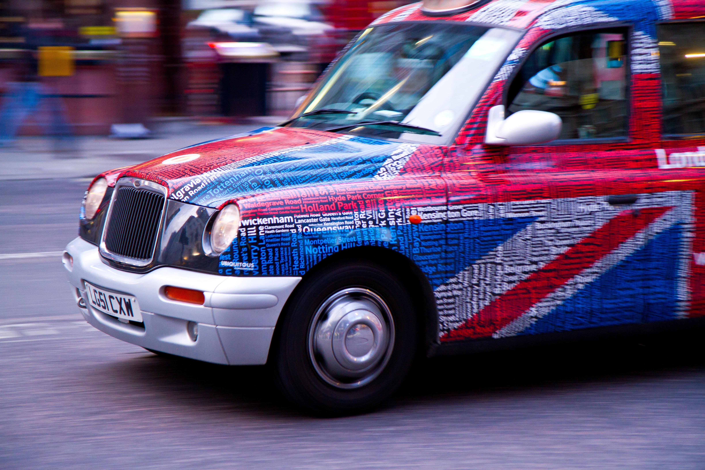
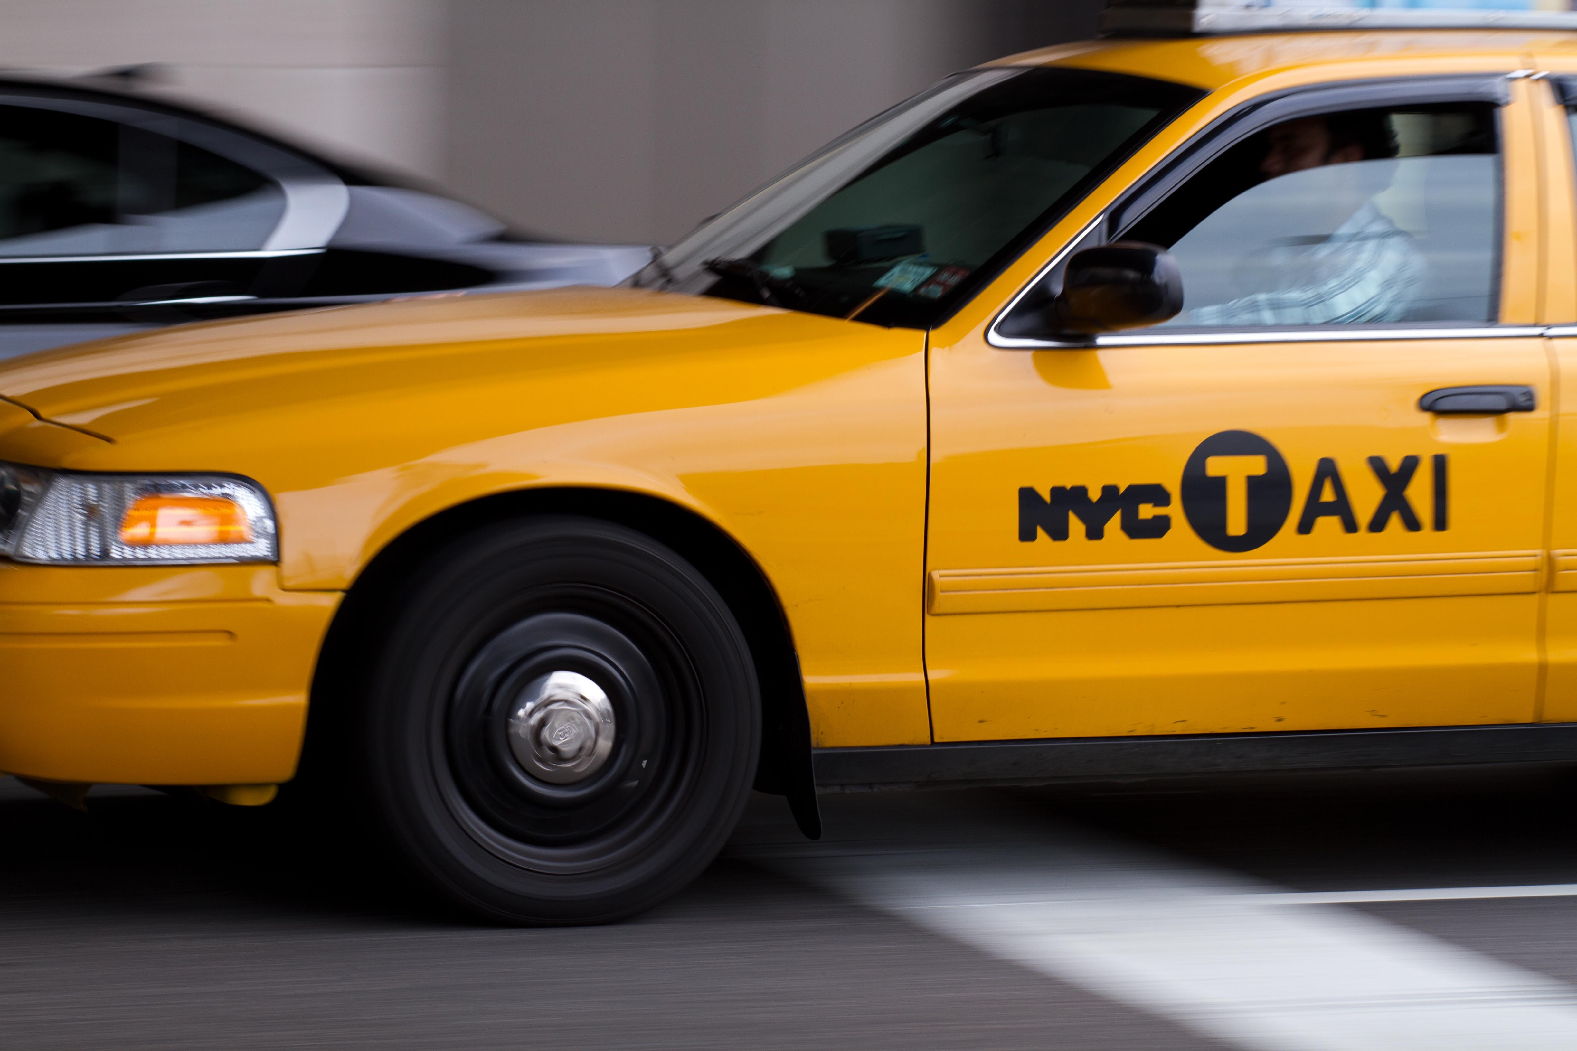
American English versus British English: Exercises

1. Different spelling
Arrange the words into the corresponding columns beneath the cloud.
dialogue favorite cosy humour favourite catalog theater catalogue
theatre to realize
dialog humor cozy meter
metre to realise

'-or' AE | '-log' AE | '-er' AE | '-z' AE

'-our' BE | '-logue' BE | '-re' BE | '-s' BE

2. Different vocabulary.
Fill in the missing equivalents.
Different words AE | Different words BE
- trunk
- mobile phone
 | - sweets
 | - queue
- faucet
 | - apartment
- soccer
- subway
 | - trousers
- schedule
- vacation

- cheque
- tyre
- jewelry

3. Different vocabulary
Fill in the blanks and get to know some typical American and British sentiments at the same time!

- In the States many city people live in their …........................, whereas few people in Britain live in .................... as it is more common to buy houses there.

- Looking at an American …........................ you at least know the state where the car is registered. For the British it seems more important to know how old a car is which can be deduced from the numbers and letters on British ….........................

- When you wait for a bus in Britain, there is often a well-ordered …........................ at the bus station. Patiently waiting in a …........................ is not every American's idea.

- British mothers often bake …........................ for 5 o'clock tea. American …........................ like to give their children …........................ and some even think that they are part of a healthy diet.

- Two friends on speaker phone in their cars: “Ups – I need to stop at the next …........................ station. I have stood on the M25 around London for too long. What about you in Atlanta?” - “There is much traffic on I-285 too, but my fuel tank is rather full. This is why I do not need to fill up at the next …........................ station on my way, but my …........................ is dirty – I cannot see the road clearly. So I need to find a …........................ station anyway.”

- Amanda, on the phone: “What are your plans for the weekend?”- Kate: “Well, nothing special, just a nice time out, this week in the city was not really interesting. I thought of going to the cinema and watch the new Fast and Furious …........................, eating …........................ which should stop me from biting my nails because of the tension. What about you in New York?” - Amanda: ”That sounds good! Actually, there is no …........................ for me this time. I am quite excited, we will go to the …........................ on Broadway tonight and see Disney's The Lion King. Unfortunately, you are not allowed to eat …........................ as it is rather formal there. Ah...reminds me, I need to prepare food and then check my wardrobe. Sorry, I need to go! Have fun, speak to you soon!” - “Thanks, the same to you, bye, dear!”

